How to Buy a Home With Bad Credit — and Improve Your Credit
Published on May 30, 2025
Credit issues play a big role in preparing to buy a home. Here’s how to avoid buying a home with bad credit.
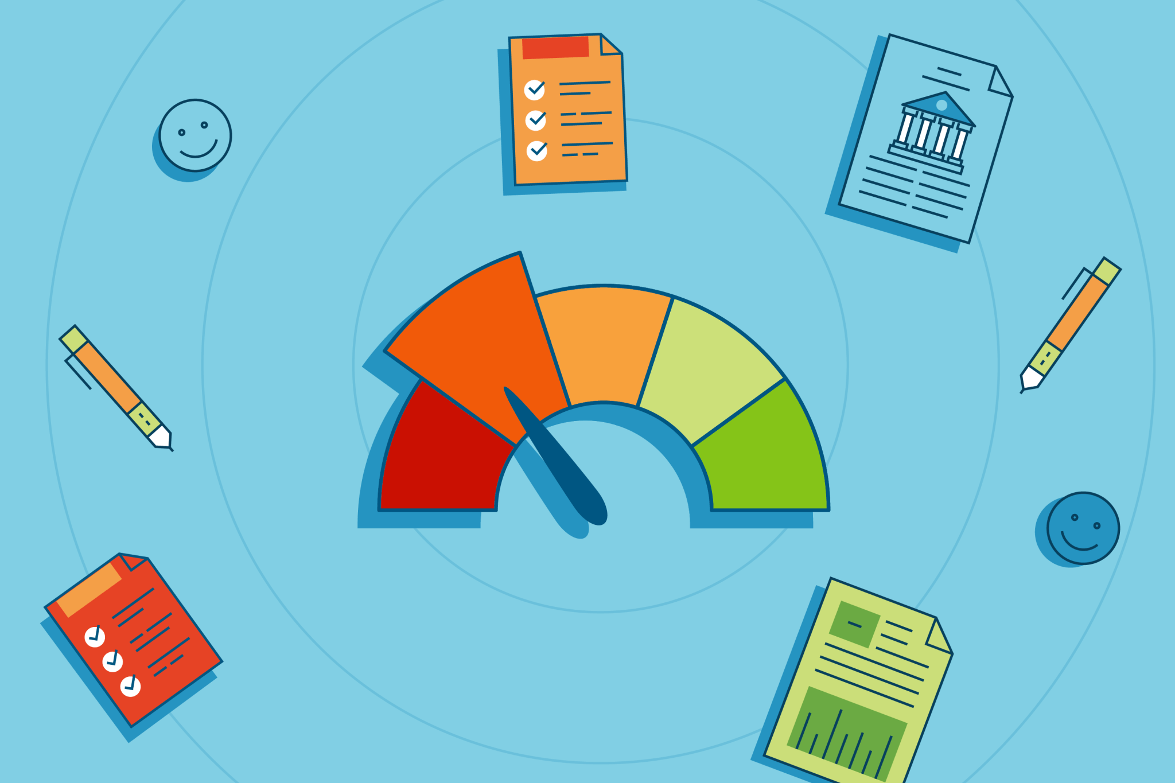
Image: HouseLogic
Too often, this scenario unfolds: A young consumer buys too much on credit while setting up a new place to live and preparing for a first job. Years later, they find their freewheeling use of credit took a big toll on their credit score. It matters now because they want to buy their first home, but they’re dealing with a low credit rating – in other words, bad credit.
Bad credit isn’t always a deal breaker, however. “Buying with bad credit is possible, but you may need to work on getting your score up, depending on how bad your credit is,” says Marco Smith, a real estate professional with The Maryland & Delaware Group at eXp Realty based in Fulton, Md. Some loan programs, such as FHA, aim to help borrowers with lower scores.
Nevertheless, a credit score is important. “When it comes to home ownership, your credit score is one of the major factors in determining what your loan terms will be,” says Brian Boruszak, senior home lending adviser at Chase Home Lending. “It’s a big part of what lenders use to assess whether you’ll be approved for a mortgage and if so, at what rate.”
Real estate and mortgage experts explain the basics and tips about buying a home with bad credit while improving your credit.
Understand and Interpret Credit Scores
A credit score is a three-digit number ranging from 300 to 850 that reflects your creditworthiness, or the likelihood you’ll pay your bills on time. A higher score indicates a person who’s considered less of a credit risk.
The score is based on:
- Payment history
- Credit utilization ratio (the amount owed)
- The length of credit history
- New credit
- Credit mix (the variety of credit accounts you have, like credit cards and other types of credit)
- New credit inquiries and account openings
The most widely used credit scores are FICO (from the Fair Isaac Corp.) and VantageScore.
What’s a Good Credit Score vs. a Bad Credit Score?
Here's where your score falls:

Average credit score for a first-time buyer, according to Lending Tree: 700
How to Get Your Credit Report
Each year, you can request to receive by mail one free copy of your credit report from the three major consumer credit reporting firms:
- Experian
- Equifax
- TransUnion
You can do this in one step at AnnualCreditReport.com. You can also review credit reports online for free once a week.
Measuring the Impact of a Credit Score
Higher credit scores can influence the types of mortgages you qualify for, including whether you’re eligible for a larger loan, a lower down payment, lower loan fees, or a lower interest rate. “Any score in the mid-700s or above is considered good and could help you qualify for lower interest rates,” Boruszak says.
Here’s an example of how a credit score translates into dollars. Earlier this year, a borrower with a credit score of 620 typically qualified for a 7.89%, 30-year fixed-rate mortgage. A home buyer with a 760 score, however, qualified for an average rate of 7.18%, according to Experian. On a $400,000 home, with 20% down, that could translate to a payment difference of about $150 more per month — or $1,800 a year.
Most lenders require a score of at least 620 for a conventional loan, which is any mortgage loan that isn’t insured or guaranteed by the government (such as under the Federal Housing Administration, the Department of Veterans Affairs, or the Department of Agriculture loan programs).
If you’re a first-time buyer with bad credit, you may have access to special loans. For example, the Federal Housing Administration may accept scores in the 500s and are a popular choice for first-time buyers.
FAQs from Potential Borrowers With Bad Credit or No Credit History
If you have bad credit, you may be looking for answers to these questions:
Can I Buy a Home With No Credit History?
“For buyers with no credit history, manual underwriting is a path forward,” says Elena Novak, a lead real estate researcher and analyst at PropertyChecker.com. The process can help applicants with a “thin credit file or low credit qualify for a loan,” according to Experian. An underwriter will review documents that verify income and assets to determine qualifications to borrow. “Lenders can review alternative data, like rent, phone, and utility payments,.” Novak explains. Such alternative reviews for on-time payments can show creditworthiness to a lender.
Potential borrowers with a limited credit history may need a co-signer on their mortgage. That’s typically a close family member with good credit, Smith says.
How Does My Credit Score Affect Loan Eligibility?
Credit scores influence what type of loan you’re eligible for. For example, conventional mortgages — the most common type of mortgage — often require a credit score of at least 620. With FHA loans, borrowers may qualify with a credit score of 500 with at least a 10% down payment or a 579 score with a 3.5% down payment.
Here are loan types and minimum credit scores from Experian:
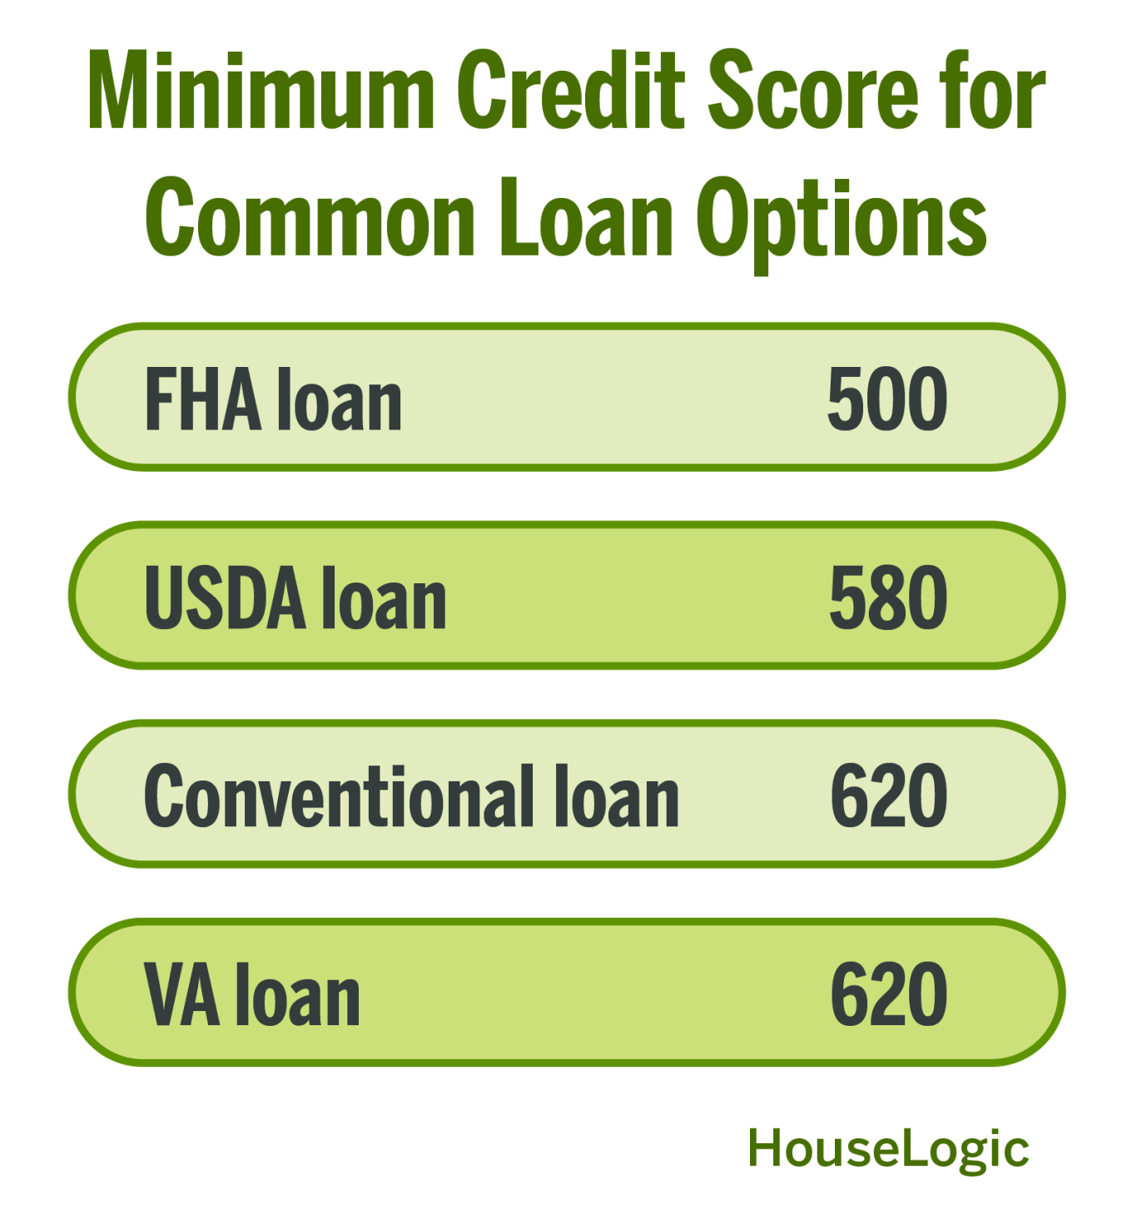
Image: HouseLogic
How Can I Improve My Bad Credit Score Fast?
Credit scores can shift frequently based on your monthly activity, Boruszak says. “Speaking with a mortgage lender and having them review your credit can help, because they can offer tips on improving your credit,” Smith explains. If you aren’t sure where to start, ask your real estate agent to recommend reputable lenders. Lenders may suggest steps like paying down debt and avoiding new credit applications to help improve your credit score.
Although you may think a credit score involves technical calculations that nonfinancial borrowers can't understand, the formula is simple. The following tips each outline actions to improve the factors that figure into a credit score. Remember, even small changes can improve scores.
Credit Improvement Tip 1: Make Payments on Time
Payment history accounts for 35% of your FICO score and is the most important factor. Any late or missed payments can significantly lower your score. Experts recommend setting up autopay for at least the minimum payments due or using programs such as Experian Boost. They will give you credit for on-time payments for expenses like rent, utilities, and cell phone bills, which could help you become more creditworthy.
Credit Improvement Tip 2: Pay Down Debt
The amount you owe makes up 30% of your score and includes your credit utilization rate: how much of your available credit you're using. Mortgage experts recommend keeping this below 30%. “Paying down high debt will boost your credit score, but high interest makes it hard to accomplish quickly, as those fees pile up each month and derail your debt repayment progress,” says Andrea Woroch, a speaker and blogger on consumer financing. You may want to explore tools like debt consolidation loans or balance transfer cards, she says. Avoid maxing out credit cards and be cautious with balance transfers if it means opening new lines of credit, because that could lower your score.
Credit Improvement Tip 3: Don't Close Old Accounts
Length of credit history makes up 15% of your score and depends heavily on your oldest account. Closing old cards can shorten your credit history and hurt your score. Consider keeping unused accounts active by charging a small recurring bill, but only if you can commit to paying it off monthly.
Credit Improvement Tip 4: Diversify Your Credit Mix
Your credit mix accounts for 10% of your score. For example, a mix of credit cards, a car loan, and a mortgage is more favorable than having just one type of credit. However, don’t try to improve this category by taking on debt you don’t need. It’s a relatively small share of your credit score, financial experts say.
Credit Improvement Tip 5: Limit New Credit Applications
New credit inquiries and account openings make up the final 10% of your score. A single hard inquiry may lower your score by only a few points, but multiple applications in a short time can have a greater impact, according to Experian. Apply for credit only when necessary. These inquiries can stay on your FICO score for up to a year.
Credit Improvement Tip 6: Monitor Your Credit Report for Errors
Review your credit reports from Experian, Equifax, and TransUnion. Errors might be accounts that aren’t yours or incorrect late payments. When you spot them, dispute them immediately with documentation. Learn how at Consumerfinance.gov.
It pays to pay attention to your credit. “Credit scores matter, because they’re one of the first things lenders evaluate when deciding whether to approve a mortgage — and on what terms,” Novak says. “A higher score doesn’t just increase your odds of approval; it also lowers your interest rate. [That] can mean saving tens of thousands over the life of a loan.”


Melissa Dittmann Tracey
Melissa Dittmann Traceyloves to talk real estate and is obsessed with the design of other people’s homes (but in a noncreepy way!). You can hear her weekly on the syndicated radio show and podcast, Real Estate Today, in her housing trends segment “Hot or Not?” She is also the creator of the Styled, Staged & Sold blog and host of The Housing Muse podcast. Follow her on Instagram or Twitter @housingmuse

